Weaving with Lolly Sticks
By Mark Warner
Age Range: 5 to 11
This is a very easy technique which most children will be able to use to create some very impressive weavings. Once they have mastered this basic skill, there are an infinite number of variations which will allow each child to make their own original lolly stick weaving.
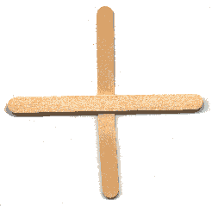
Resources - Each child will need two lolly sticks and some wool.
Technique:
1) Start by placing your two lolly sticks in the cross shape shown on the right. You might want to glue them together to hold them still, although the wool will hold them in place when you start weaving.
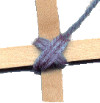
2) Start by wrapping the wool around the intersection in an X motion, as shown on the left.
3) Once this is done, look at the diagram and follow the instructions below:
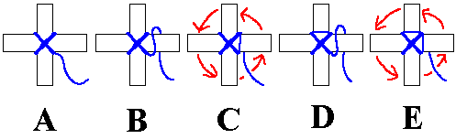
A - After you have made your X in the centre, put the end of the wool in the bottom-right hand corner.
B - Now, wrap the wool over the right end of the horizontal lolly stick, and pull it behind
C - Pull the wool lightly to remove any slack (not too tightly) and rotate the sticks ANTI-CLOCKWISE by 90 degrees.
D - Put the end of the wool in the bottom-right hand corner, and again wrap it over and behind the horizontal lolly stick.
E - Pull the wool lightly, turn 90 degrees (anti-clockwise again) and wrap.
4) Repeat this process (WRAP, PULL, TURN, WRAP, PULL, TURN...), moving towards the ends of the lolly sticks
5) When you reach the ends (leave about 1cm at the end of the stick showing), to stop it untangling, get a large needle and thread the end of the wool into the back of the weaving, or tie the wool around one of the ends of the sticks.
Here is what your finished weaving should look like...
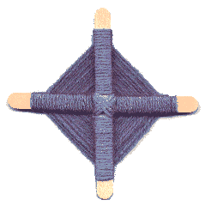
Variations
- Change the colour of the wool half-way through.
- Weave using two different coloured lengths of wool (at the same time).
- Change the direction you weave in halfway through.
- EXPERIMENT!
Why not make lots of these, then glue them together to make a large wall-hanging / classroom decoration...
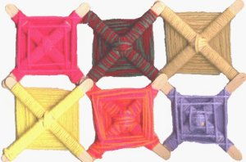
A display, created by children using this technique, can be seen on Teaching Photos.
Jane has made the following comment, which provides another use for this technique... "Great Idea. I am going to use different lengths of lolly stick to make a cross shape for an Easter activity. Thank you."

